25] PySpark MlLib - Classification

1) Pull the extracted notes in UBUNTU_HOME/test-jupyter/P2/M4/SM3

2) Import the notes in the Jupyter notebook.

3) Follow the instructions based in the notes

* Code/Dataset

data/3_Classification.rar

data/3_Classification_Solution.rar

TimeLine = 40 Mins

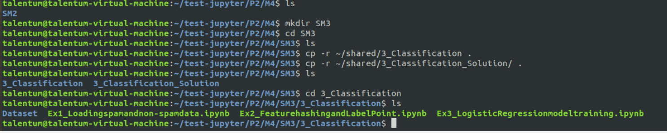

Pwd-- /home/talentum/test-jupyter/P2/M4/SM3/3_Classification

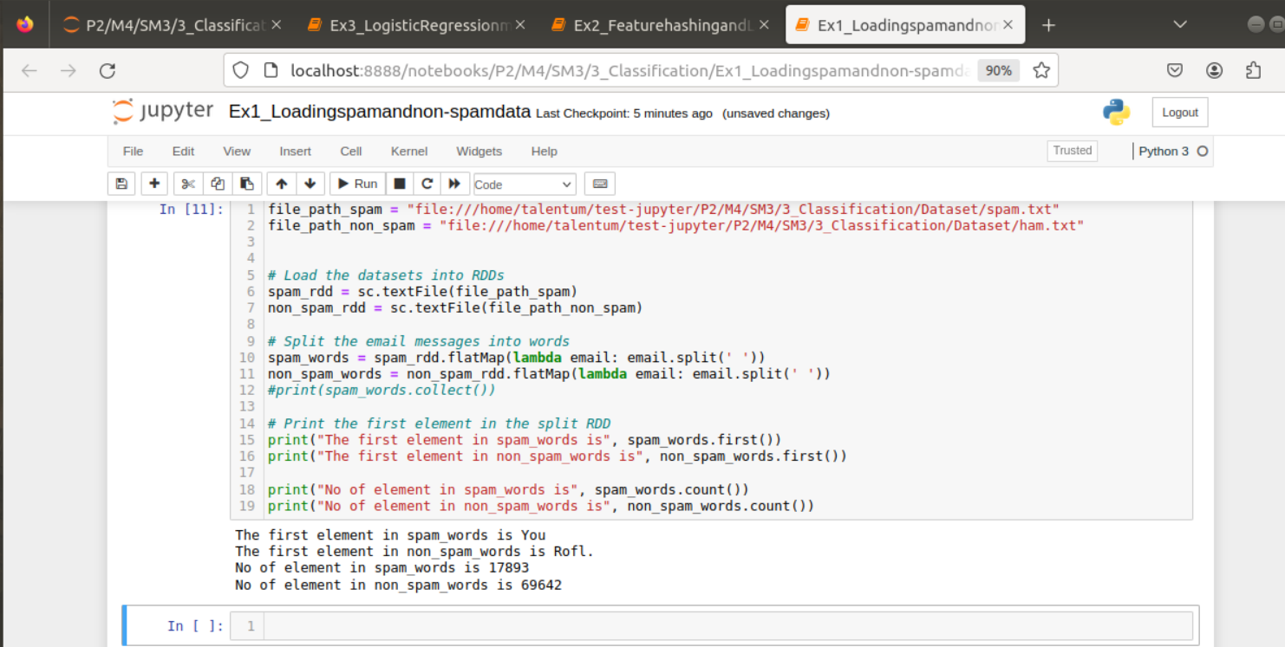

2

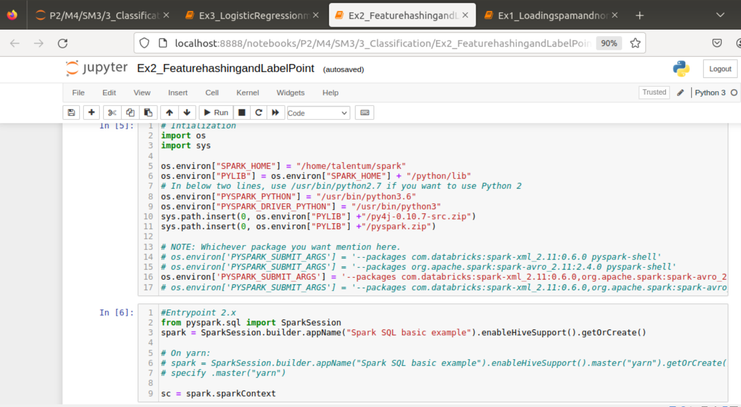

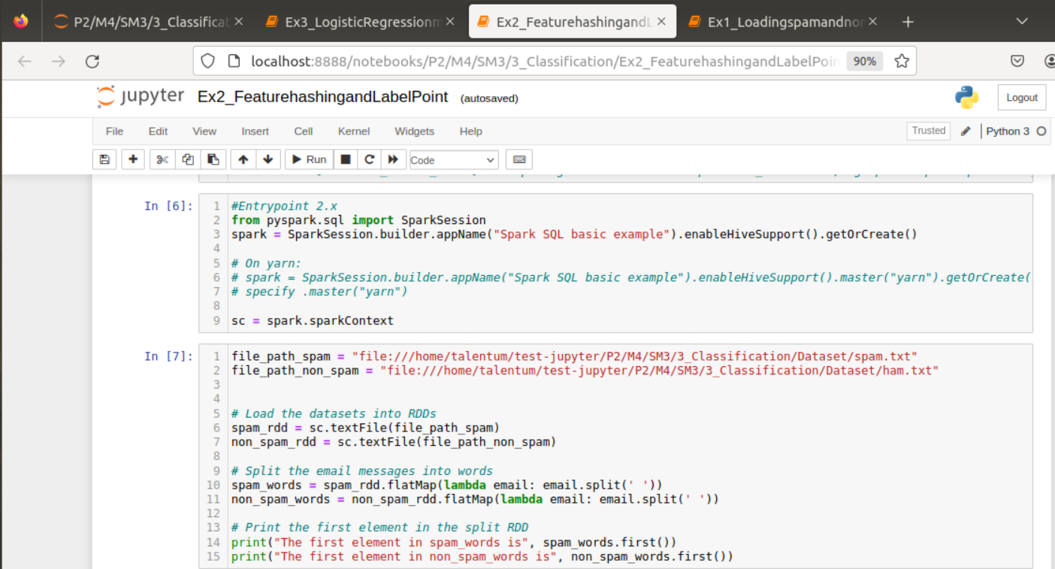

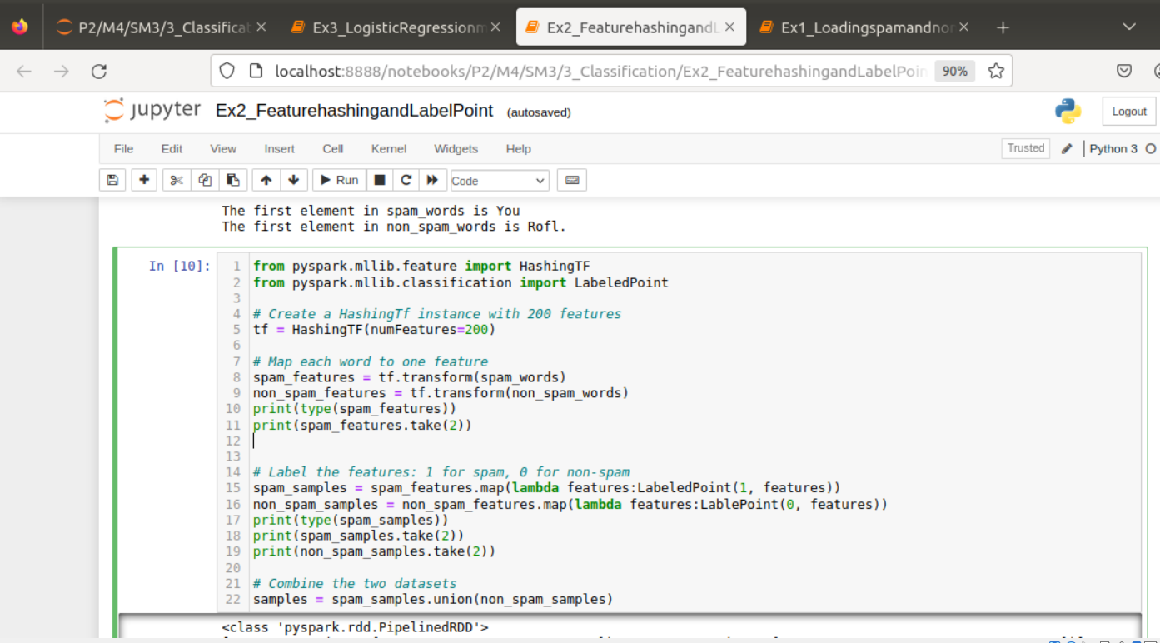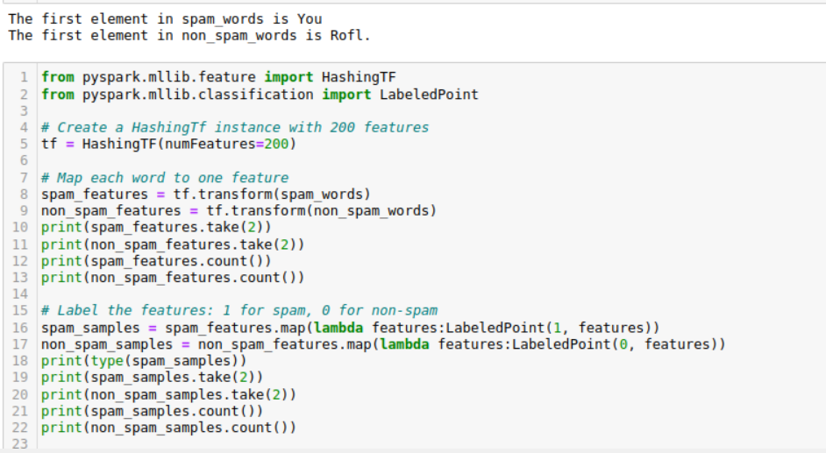

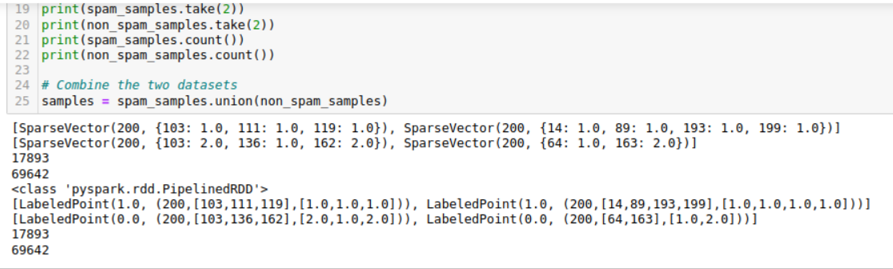

3

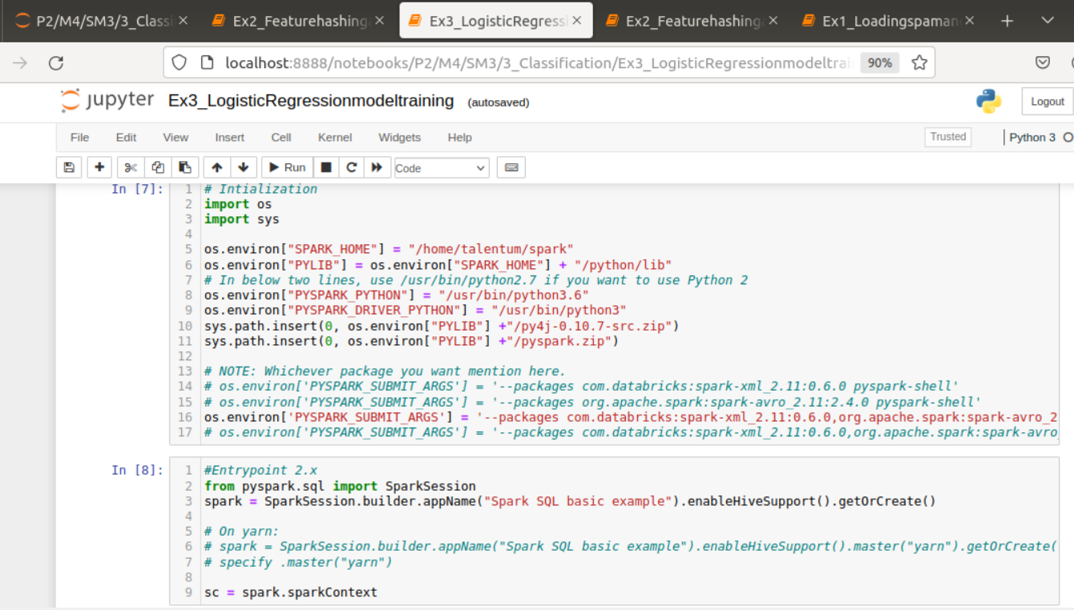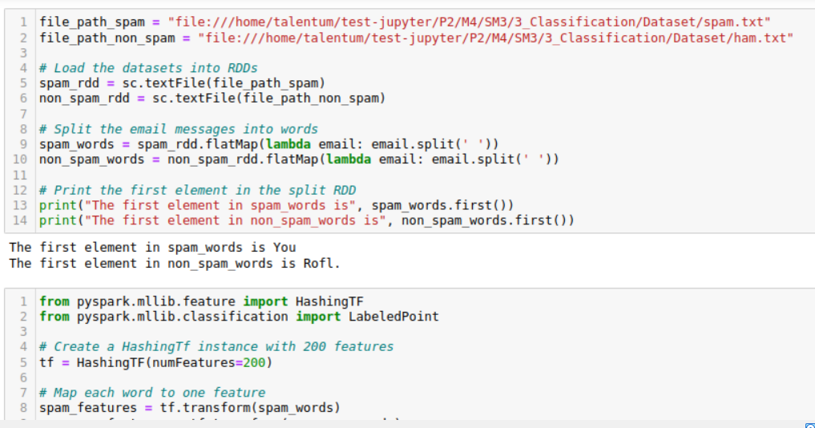

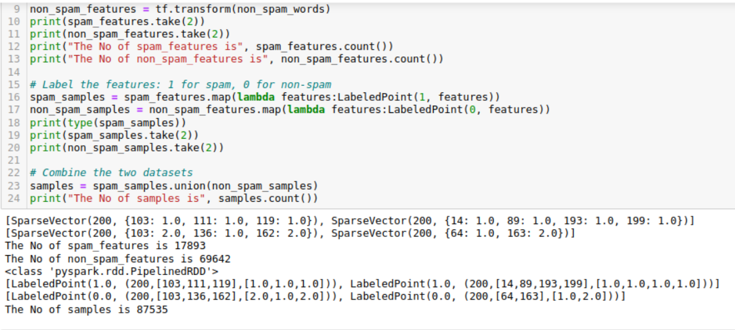

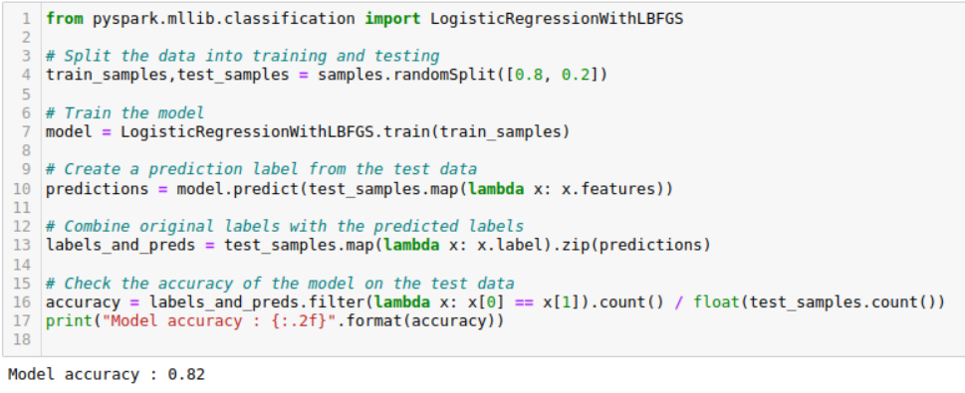

26] PySpark MlLib - Clustering

1) Pull the extracted notes in UBUNTU_HOME/test-jupyter/P2/M4/SM4

2) Import the notes in the Jupyter notebook.

3) Follow the instructions based in the notes

* Code/Dataset

data/4_Clustering.rar

data/4_Clustering_Solution.rar

TimeLine = 40 Mins

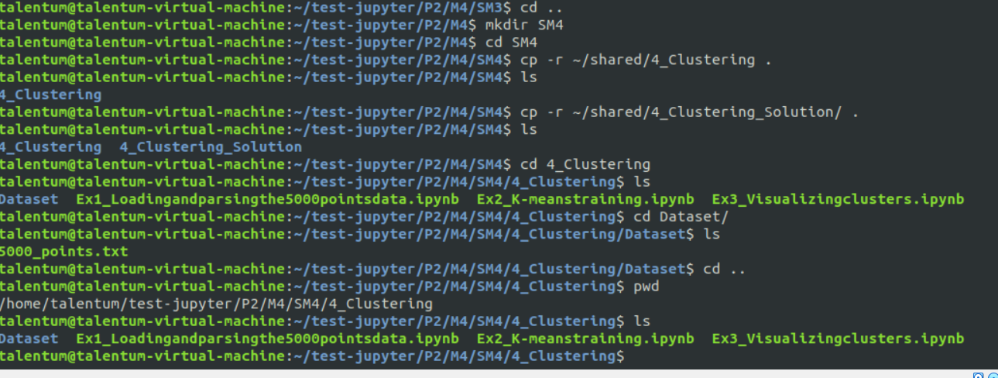

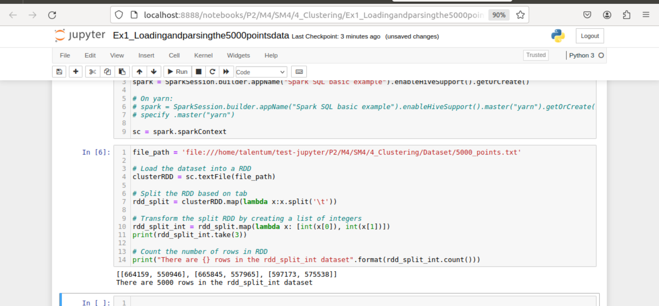

2)

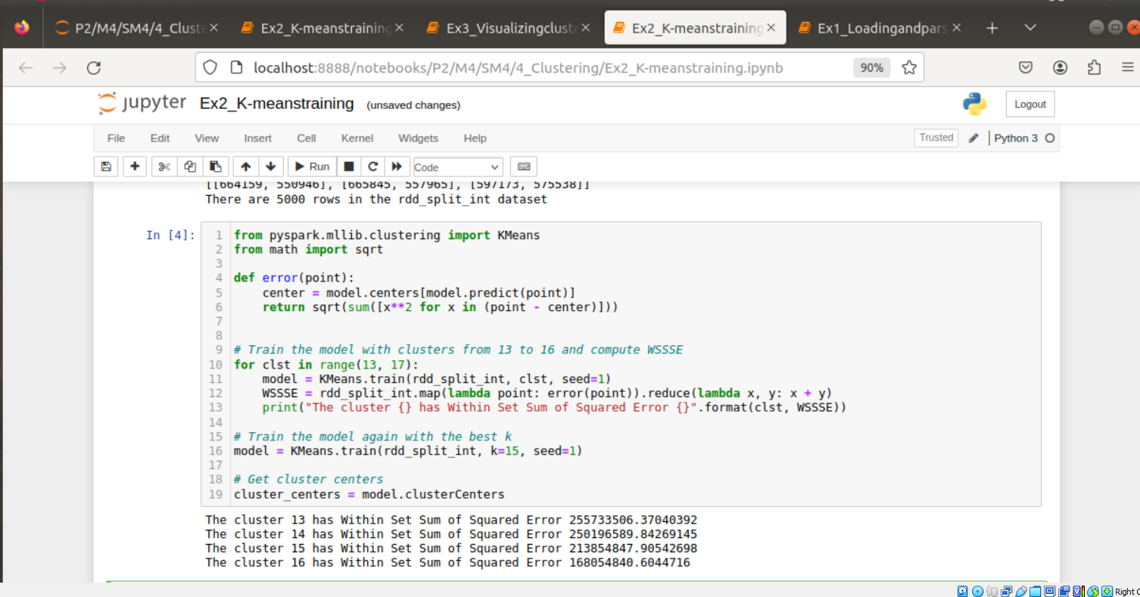

3)

